[*This document is as same as Q2c and Q2d in the PRS sample paper that is shared in Canvas.*]

The global generation of waste electrical and electronic equipment (WEEE), or e-waste, is estimated to be 30–50 million tons per year. Although WEEE has a high recycling value, many WEEE items also contain hazardous substances that must be separated from the municipal waste stream. Waste collection companies rely on the involvement of society to properly dispose of e-waste. Different collection methods have been offered, which include collection at supermarkets and electrical and electronic equipment stores, and municipal collection centers. Other methods include mobile collection, such as curbside collection, and on-demand collection, where the resident can request that the material be collected from a household. On-demand collection may be suitable for efficiently planned waste collection, especially in city centers.

Beyond the collection of the e-waste, there is also a need to sort e-waste into categories for easier handling in later processes. Machinew, an AI company founded in Singapore, is considering building a robotic sorting system for small appliances. The system will use artificial intelligence to identify objects on a conveyor belt. The AI will identify the brand of the appliances, the type of electrical appliances, and the recycling value of the electrical appliances (See Table 1 for more detail).

Table 1.

|  |  |  |
| --- | --- | --- |
| Brand | Type | Value |
| Cornell | Kettle | Low |
| Electrolux | Vacuum cleaner | Mid |
| Eurospace | Microwave oven | High |
| Hitachi | Rice cooker |  |
| LG | Air Fryer |  |
| Mayer | Food steamer |  |
| Midea | Toaster |  |
| Panasonic | Pressure cooker |  |
| Samsung | Coffee machines |  |
| Sharp | Irons |  |
| Philips | Sewing machines |  |
| Tefal | Sandwich maker |  |
| Mistral | Blender |  |
| Rowenta | Juicer |  |
| Braun | Mixer |  |
| Iona | Slow cooker |  |
| Sona | Hair dryer |  |
| Bosch |  |  |

After the identification, a series of robotic arms will pick up the object and place it into the correct bin. The company believes the system is much more efficient compared to human workers. In general, manual picking usually involves 15 picks per minute, however, this sorting robot should be able to perform up to 70 picks every minute. This will significantly reduce operating costs and improve overall productivity.

In this exciting venture, you are assigned to a team that builds the AI system that can (1) identify the brand, the type, and the value of the appliances on a conveyor belt using the camera mounted on the robotic arm; (2) provide predictive maintenance for the conveyor belt using its built-in vibrant sensor and acoustic sensor, which record operation data of the conveyor belt.

**Question 2c**. To preserve the smart sorting system performances, your developed AI system requires to have a predictive maintenance module using the vibration sensors mounted on the conveyor belt. The **anomaly detection** mechanism notices the occurrence of equipment anomaly by detecting that the equipment is different from usual. You have collected a vibration signal dataset in the past month. The dataset has 3,000 normal vibration signal sequences and 2 abnormal vibration sequences (that rarely happen in operation). Each sequence has a duration of four seconds and a sampling rate of 50 Hz. Figure 1 demonstrates the comparison between a normal and an abnormal signal sequence, including their original signal sequences, their histograms (10 bins), and their frequency-domain statistics (20 dimensions, such as mean, median variance, etc). To identify the abnormal sequence, your colleague has suggested an approach as described in Table 2. **List two challenges that you could face using this proposal and suggest solutions to address these challenges. Provide your justifications in the context of the data presented in Figure 1.**

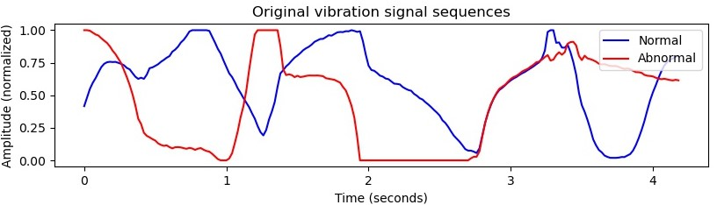

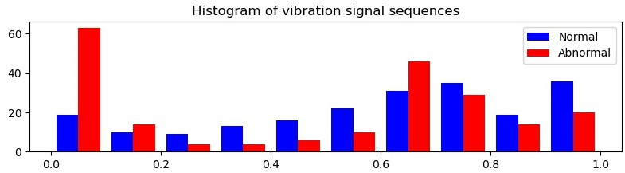

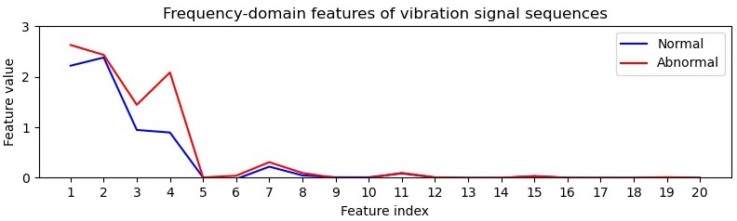

Figure 1. A comparison of normal and abnormal vibration signal sequences.

Table 2. An abnormal vibration signal detection proposal was suggested by your colleague.

|  |  |
| --- | --- |
| Feature extraction module | Firstly, extract the 10-bin spatial-domain feature and 20-dimensional frequency-domain feature from the input vibration signal sequence.  Secondly, concatenate these two features to be 30-dimensional features, which be used as input to the following classification module. |
| Classification module | Develop a multiple-perception-layer neural network model to perform two-category classification using your collected dataset described in the question. |

**Question 2d**. The **anomaly diagnosis** mechanism of your developed AI system identifies the cause of equipment anomaly and the equipment condition at that time. When an anomaly occurs, the cause is quickly isolated and recovery action is taken. Table 3 lists the maintenance record of the conveyor belt in the past year. The vibration sensory data has three categorical measurements: ‘Large’, ‘Fair’, and ‘Small’. The acoustic data have two categorical measurements: ‘High’ and ‘Low’. The failure cause is also recorded, where there are two causes ‘Carryback’ (the material remains on the belt after the electronic waste is discharged) and ‘Mistracking’ (the conveyor belt rides unevenly on rollers, favoring one side over the other). **You are asked to build a naïve Bayes model to make a decision based on the vibration measurement ‘Fair’ and acoustic measurement ‘Low’. Show your calculation to justify your developed model.**

Table 3. The maintenance record of the conveyor belt.

|  |  |  |  |
| --- | --- | --- | --- |
| Maintenance record No. | Vibration sensory data measurement | Acoustic data measurement | Cause |
| 1 | Large | High | Carryback |
| 2 | Fair | High | Mistracking |
| 3 | Small | High | Mistracking |
| 4 | Large | High | Carryback |
| 5 | Fair | Low | Mistracking |
| 6 | Small | Low | Carryback |
| 7 | Large | Low | Mistracking |
| 8 | Fair | Low | Carryback |
| 9 | Small | Low | Carryback |